Project Synopsis
on
DevelopersBay
Submitted as a part of course curriculum for

Bachelor of Technology
in
Computer Science



Submitted by
Aaryan Singh (1900290120003)
Harsh Srivastava (1900290120042)
Mohd. Aman (1900290120066)
Project ID: PCS23-4
Under the Supervision of
Dr. Gaurav Dubey
Assistant Professor

KIET Group of Institutions, Ghaziabad
Department of Computer Science
Dr. A.P.J. Abdul Kalam Technical University
2022-2023

DECLARATION

We hereby declare that this submission is our work and that, to the best of our knowledge
and belief, it contains no material previously published or written by another person nor
material which to a substantial extent has been accepted for the award of any other degree
or diploma of the university or other institute of higher learning, except where due
acknowledgement has been made in the text.

Signature of Students:

Name:
- Aaryan Singh - 1900290120003
- Harsh Srivastava - 1900290120042
- Mohd. Aman - 1900290120066

Date: 06/09/2022

CERTIFICATE

This is to certify that Project Report entitled “DevelopersBay” Project Id: PCS23-4 which is submitted by Aaryan Singh, Harsh Srivastava and Mohd. Aman in partial fulfilment of the requirement for the award of degree B. Tech. in Department of Computer Science of Dr A.P.J. Abdul Kalam Technical University, Lucknow is a record of the candidates own work carried out by them under my supervision. The matter embodied in this report is original and has not been submitted for the award of any other degree.

Date: Supervisor Signature

Dr. Gaurav Dubey
Assistant Professor

ACKNOWLEDGEMENT

It gives us a great sense of pleasure to present the synopsis of the B. Tech Mini Project undertaken during B.Tech. Third Year. We owe a special debt of gratitude to Dr. Gaurav Dubey, Professor, Department of Computer Science, KIET Group of Institutions, Delhi- NCR, Ghaziabad, for her constant support and guidance throughout the course of our work. Her sincerity, thoroughness and perseverance have been a constant source of inspiration for us. It is only her cognizant efforts that our endeavours have seen the light of the day.
We also take the opportunity to acknowledge the contribution of Head of the Department of Computer Science, KIET Group of Institutions, Delhi- NCR, Ghaziabad, for his full support and assistance during the development of the project. We also do not like to miss the opportunity to acknowledge the contribution of all the faculty members of the department for their kind assistance and cooperation during the development of our project.
Last but not the least, we acknowledge our friends for their contribution to the completion of the project.

Signature:

Date: 06/09/2022

Name:
- Aaryan Singh – 1900290120003
- Harsh Srivastava - 1900290120042
- Mohd. Aman - 1900290120066

ABSTRACT

Technology is booming rapidly from year to year and social media platforms have become an integral part of it, today we have multiple worldwide social media platforms upon which people can connect with different peoples all around the world of different domains, form communities make connections etc.

It is a reality that every social media platform which are active worldwide allow everyone or anyone to be a part of it or use it, there are no concentrated platforms which target only specific group of audience, and it seems like we are in a dire need of one.

A concentrated platform can have many benefits like clarity of usage which means that any one specific individual can be aware that he can make use of that platform or platform can benefit him or not by simply checking if he belongs to that group of audience which platform is targeting, in this way traffic on platform will become homogenous and also people can save their time by quickly analysing whether they want to be a part of it or not.

In our domain what we aim to do is to build a fully-fledged social media platform which is only targeted for developers all around the world, so that they can help each other to improve, can form a worldwide homogenous community through this platform, experts can guide beginners and beginners can upgrade their skills, share their improvement, communicate with experts. Experts can also connect with other experts and collaborate with them for mega projects etc.
Every developer on platform can see projects and repositories of their connected developers and of those developers who have made their repository links and projects public and will also be able to search for someone with whom peer programming can be done. The platform will also support the feature of mock interviews and messaging, project ideas. In this way every developer can get new ideas, vision, proper guidance, and resource for their future ventures.
The main motivation and vision behind the whole project is to help each developer around the world to improve upon their skills and to form a homogenous community through this platform so that it helps in increasing human resource around the world and every developer gets all his needs fulfilled at one place itself.

LIST OF FIGURES

Name Page No:
- Flowchart of Website 12

- Diagrammatic Representation 15

TABLE OF CONTENTS

 | Page No.
TITLE PAGE .................................................................................................................... | i
DECLARATION .............................................................................................................. | ii
CERTIFICATE …........................................................................................................... | iii
ACKNOWLEDGEMENT.................................................................................................. | iv
ABSTRACT...................................................................................................................... | v
LIST OF FIGURES .......................................................................................................... | vi
CHAPTER 1 INTRODUCTION | 1-2
1.1 Introduction ……………………................................................... | 1
1.2 Problem Statement.…………………….......................................
1.3 Objective………………………………………………………… | 2
1.4 Scope …………………………………………………………….
CHAPTER 2 LITERATURE REVIEW…………………………………………….... | 3-11
CHAPTER 3 PROPOSED METHODOLOGY …………………………………........ | 12-13
3.1 Flowchart | 12
3.2 Algorithm Proposed | 13
CHAPTER 4 TECHNOLOGY USED ……….……………………….…………. | 14
CHAPTER 5 DIAGRAM …........................................................................................... | 15
CHAPTER 6 CONCLUSION …....................................................................................... | 16
REFERENCES….............................................................................................................. | 17

CHAPTER-1
INTRODUCTION

  - INTRODUCTION

Technology is booming rapidly from year to year and social media platforms have become an integral part of it, today we have multiple worldwide social media platforms upon which people can connect with different peoples all around the world of different domains , form communities make connections etc.

A concentrated platform can have many benefits like clarity of usage which means that any one specific individual can be aware that he can make use of that platform or platform can benefit him or not by simply checking if he belongs to that group of audience which platform is targeting, in this way traffic on platform will become homogenous and also people can save their time by quickly analyzing whether they want to be a part of it or not.

  - PROBLEM STATEMENT

It is a reality that social media platforms which are active worldwide allow everyone or anyone to be a part of it or use it, there are no concentrated platforms which target only specific group of audience and it seems like we are in a dire need of one.

A concentrated platform can have many benefits like clarity of usage which means that any one specific individual can be aware that he can make use of that platform or platform can benefit him or not by simply checking if he belongs to that group of audience which platform is targeting, in this way traffic on platform will become homogenous and also people can save their time by quickly analyzing whether they want to be a part of it or not.

  - OBJECTIVE

In our domain what we aim to do is to build a fully-fledged social media platform which is only targeted for developers all around the world, so that they can help each other to improve, can form a worldwide homogenous community through this platform, experts can guide beginners and beginners can upgrade their skills, share their improvement, communicate with experts. Experts can also connect with other experts and collaborate with them for mega projects etc.
Every developer on platform can see projects and repositories of their connected developers and of those developers who have made their repository links and projects public and will also be able to search for someone with whom peer programming can be done. The platform will also support the feature of mock interviews and messaging, project ideas. In this way every developer can get new ideas, vision, proper guidance, and resource for their future ventures.

  - SCOPE

The main motivation and vision behind the whole project is to help each developer around the world to improve upon their skills and to form a homogenous community through this platform so that it helps in increasing human resource around the world and every developer gets all his needs fulfilled at one place itself.

CHAPTER-2
LITERATURE REVIEW

FROM DESKTOP TO MOBILE VIEW: A SIMPLIFIED APPROACH TO MOBILE WEBSITE DEVELOPMENT

Authors: Shagoofah Golamgous, Yasser Chuttur, Priyanca Jogoo
Journal: 2019 Conference on Next Generation Computing Applications (NextComp)
Desktop version websites are designed for viewing on desktops or laptops screens and are not optimized for mobile devices. With increased adoption of mobile technologies, businesses and governments, which already own a desktop version website but not a mobile version website is often required to invest heavily in a full web development life cycle to obtain a website optimized for mobile devices. Given that website development is complex, time consuming and costly, we propose a simplified approach in the form of a tool, which makes use of open-source technologies to automatically convert existing desktop websites into mobile versions without the need to go through a complete website development life cycle. The proposed tool presented in this paper particularly targets, but is not limited to, Governments from developing countries with strict budget constraints.
Web development is complex, costly and demands several considerations like good project management and web development skills. Developing a mobile version for a website would normally require that all the typical stages of web development be repeated. Such approach is not only expensive but also unnecessary.

In this paper, the components and content prioritization algorithm of a website conversion tool that make use of open software has been presented. The presented tool is particularly interesting for institutions seeking a simple, rapid and economical solution to obtain mobile versions of their existing desktop versions websites. Preliminary results indicate that our tool can effectively extract contents from a desktop website version to automatically create a corresponding mobile version. Website administrators can further use Google analytics and other resources to customize the proposed algorithm so as to suit their specific needs.

The State of Website Security

The most immediate action to take is to remove the silos separating IT security from the development team.
Only 63 percent of the website vulnerabilities that security teams find after applications have gone live are remediated. This indicates that many vulnerabilities still go unresolved despite the threat they pose to the business. This is compounded when we look at the remediation rates of the energy, education, and manufacturing sectors, which showed the lowest rates at 40, 46, and 50 percent, respectively.

Senior-level IT decision-makers need quite a bit more education to help them understand an application security program’s business value. Often, the process of securing a business involves either checking off boxes in a compliance document or simply buying products out of habit.

Enforcing more secure practices and faster, custom patching of vulnerabilities in third-party applications will likely be two of the most difficult tasks. Clearly, we must educate the right people across IT and development to mitigate the issue of application security at the source.

The Design and Development of Computer Network Quality Course Website.

During the construction of computer network quality course to improve the quality of computer network course, the paper designs and develops the computer network quality course website. The development of the website is based on BIS architecture and MVC design pattern and adopts the Struts framework. The website is enough to incarnate the user- centered development idea and provides an excellent intercourse platform for teachers and students.

The paper shows the design of the website function modules, and specifically describes the development of main function modules and the update and maintenance of the website.

The computer network quality course website is primarily based on the principles that-"practicality, effectiveness, comprehensiveness, and convenience". So we will make the website not only become a declaration platform of computer network quality course construction, but also become a long-term working platform which is used to do conventional teaching, students self- examination, teacher-student interaction and teaching arrangement. After the website put into use, it is not only making the student fully and rationally use a variety of the teaching resources, but also stimulates the self-learning initiative of the student. The website is enough to incarnate the user-centered development idea and provides an excellent intercourse platform for teachers and students.

The website maintenance is a very important task during the later operation. The regular update and maintenance will have established effect.

Metrics of Social Websites: A Case Study

Social Networks are the common platform for the present generations to share ideas. The members of these sites have grown to billions in the last decade and much more at present. In this paper, the metrics Page Rank, Path Length, Clustering Coefficient and Vertex Degree for SNWSs are evaluated by users’ database of Facebook. The results indicate that the metrics Page Ranking, Path Length and Vertex Degree first three and last hold highest values and form an edge with the actors. The other metric Clustering Coefficient is reciprocal to the above metrics and the higher the value the greater isolation in the sub- group causing formation of Clique.
Social networks are the platforms in which the process of interaction is a common agenda. Here the way of exchange of ideas between a pair of members is by means of various channels – like text messaging, voice chatting, photo sharing, etc.
The involvement of a user either with the family or friends local or global irrespective of country, culture, community affects his personality.

In addition to that the users involved in their respective way of interactions and kind of interesting topics which are selected by him or a group an individual involves in different issues with different ideas among different people can become popular and versatile.

Systems and software engineering - Engineering and management of websites for systems, software, and services information

Websites are often developed to serve a number of purposes and users of different technical backgrounds.
Therefore, the site should be designed to allow users to easily gain an overview of the scope of the content and functionality provided. The introductory pages of the site should include a description of the purpose and intended uses of the website, with links to topics accessible within one link or search which satisfy the information needs of casual users. Global navigation features and search functions should allow more technical users to quickly reference needed information.

The structure (site map) should reflect the information-seeking tasks to be performed by the users, allowing them to readily grasp the site's organization and find the needed information. The structure should be visible on every page, such as through menus, tabs, or display of higher-level pages in a breadcrumb trail. When the users' task is primarily to find technical information, the site structure should reflect the logical organization of the enterprise or the products, services, systems, procedures and instructions, or concepts to be presented. The site organization should place frequently used information where it is readily accessible (one click) from the main website page (home page). Frequently used features like search, and site logon, logout, and registration (if applicable) should also be readily visible on the home page. A well organized site structure can also simplify maintenance and sustainment of the site as information is added or archived in the future. Page content should be classified as stable or dynamic and the likely frequency of changes and updates should be identified.
A simple example is using color in Web pages. Explicit incorporation of color is one option; style sheet incorporation of color is another. The same color scheme can be applied to a diverse set of pages in a consistent way using a style sheet, reducing coding and maintenance effort. common style sheet, rather than changes to the many pages using that plan, can accomplish a change in the color scheme. Moreover, specific user communities may want or need to override the color selection put forward by the design (visual impairments for example), which is only viable with a mechanism such as cascading style sheets. Effective websites are designed to minimize the sustainment effort needed to change the website content.

TensorFlow: A System for Large-Scale Machine Learning

Authors: Martín Abadi, Paul Barham, Jianmin Chen, Zhifeng Chen, Andy Davis, Jeffrey Dean,
Matthieu Devin, Sanjay Ghemawat, Geoffrey Irving, Michael Isard, Manjunath Kudlur, Josh Levenberg, Rajat Monga, Sherry Moore, Derek G. Murray, Benoit Steiner, Paul Tucker, Vijay Vasudevan, Pete Warden, Martin Wicke, Yuan Yu, and Xiaoqiang Zheng.

Journal: Proceedings of the12th USENIX Symposium on Operating Systems Design and Implementation (OSDI ’16).

TensorFlow is a machine learning system that operates at large scale and in heterogeneous environments. Tensor-Flow uses dataflow graphs to represent computation, shared state, and the operations that mutate that state. It maps the nodes of a dataflow graph across many machines in a cluster, and within a machine across multiple computational devices, including multicore CPUs, general-purpose GPUs, and custom-designed ASICs known as Tensor Processing Units (TPUs). This architecture gives flexibility to the application developer: whereas in previous “parameter server” designs the management of shared state is built into the system, TensorFlow enables developers to experiment with novel optimizations and training algorithms.

TensorFlow uses a single dataflow graph to represent all computation and state in a machine learning algorithm, including the individual mathematical operations, the parameters and their update rules, and the input pre-processing. The dataflow graph expresses the communication between sub computations explicitly, thus making it easy to execute independent computations in parallel and to partition computations across multiple devices.

TensorFlow supports a variety of applications, with a focus on training and inference on deep neural networks. Several Google services use TensorFlow in production, we have released it as an open-source project, and it has become widely used for machine learning research. In this paper, we describe the TensorFlow dataflow model and demonstrate the compelling performance that Tensor-Flow achieves for several real-world applications.

Machine Learning Algorithms for Recommender System - a comparative analysis

Authors: Anand Nautiyal, Mahendra Prasad, Satya Prakash Sahu

Journal: International Journal of Computer Applications Technology and Research Vol-6 (2007)

Recommendation system is one of the most popular applications of Artificial Intelligence which attracts many researchers all over the globe. The advent of the Internet era has brought wide implementation of recommendation system in our everyday lives. There are many machine learning techniques which can be used to realize the recommendation system. Among all these techniques we are dealing with Content Based Filtering, Collaborative Based Filtering, Hybrid Content-Collaborative Based Filtering, k-mean clustering and Naive Bayes classifier. We have exploited these algorithms to their extreme in order to achieve the best possible precision and have presented a comprehensive comparative analysis. The strength of all these algorithms can be clearly realized by the significant enhancement in the accuracy, depicted by the experimental analysis taking cold start problem into consideration.

The Content Based Filtering considers the items rated by a user to formulate the future recommendations while exploring the internet services. There can be many users who must be having the same pattern of rating an item as the user intended. The k-mean is a non-parametric classification technique. It distributes the items into k clusters according to their proximity to one another. In this paper, this proximity is being measured by using the Euclidean distance.

All the algorithms described in this paper are compared with respect to their precision rates. This comprehensive analysis depicts the strength and the weakness of each one of them in different versions of the MovieLens dataset. The experiments performed are the witness of the sparsity handling by these algorithms. With this paper, we have achieved encouraging results from all these algorithms. In the real time sophisticated recommendation systems there is a need of high accuracy. Such systems still have space for improvement. There are several machine learning algorithms which can be applied to these real time systems. It is worthwhile to examine those other algorithms to improve the precision further.

Recommendation System Using Machine Learning

Authors: Suhasini Parvatikar, Dr. Deepa Parasar

Due to increase of data on internet, there is an increased dependency on internet by people Thus, recommendation systems help people by suggesting products where is overload of information on ecommerce websites. There are various methods for recommendation. This paper study about various techniques used in designing of recommendation system with machine learning algorithm.

The users find difficulty to make decision about which product to choose with vast amount of information available to them. Recommender Systems have come-up in response to this problem by learning from users’ behaviour and recommending items that are similar to their interest. Thus, the Recommender system helps user to find perfect choice of item required on ecommerce sites.

The proposed hybrid recommendation system combines clustering and association mining. The main focus of authors was to find solution on CBF challenge ie cold start problem. The proposed algorithm works as follows.: In first step, user clusters are formed. These clusters are formed on the basis of similarity calculated by cosine similarity method, thus using collaborative filtering. In second step, each cluster is converted to transactional database.

Recommendation System is most important part of life. Due to recommendation system, online shopping has gained much popularity. Adequate services are being provided by recommender system. Thus, recommender system has proved a gift for the society which helps customer to decide among their choices. The recommender system uses several approaches for recommendation.

Mock-up-driven fast-prototyping methodology for Web application development

Authors: Jia Zhang, and Jen-Yao Chung

Journal: Software Practice and Experiences (2003)

Web application development can be very complicated without an appropriate framework, architecture and application model. A good implementation model can help application developers communicate with clients, consolidate the design before starting the development, speed up the development, and make the code highly reusable. This paper proposes a mock-up-driven fast prototyping methodology (MODFM) for the development of Web applications. It is built on the most recent Web technologies: EJB, JSP, Servlet, XML, Struts, and Web application server. A two-tier Model-View-Controller (MVC) architecture is proposed
as the underlying backbone and a supporting environment is tailored specifically in order to enable development. Two basic supporting tools are provided: the dynamic menu generator and the generic code generator, which produce code for front-end, back-end and database schemas. MODFM helps to generate fully functional mock-up systems for the client to review at an early analysis stage and continues to provide guidance throughout follow-on development phases. Real-life experiences on the use of this methodology in industry are presented as examples.

Automatic code generation is becoming increasingly common and useful in software development, a result of the need to hide complexity from the software developers and the acceptance of various standards and de facto standard application programming interfaces. By using a code generator one can automate the process of some tedious, repetitive, and error-prone coding tasks. Thus, it will greatly reduce developers’ coding time and debugging time.

MODFM is an architecture-based methodology that guides developers to quickly construct a prototype of a Web application. MODFM applies a top-down approach to functionally decompose a system into Web pages organized in a menu system, while generating all the code, from the front-end all the way to the back end, integrating it into a running mock-up system. While analysis efforts are unavoidable in any development cycle, MODFM reduces this effort by loosely coupling the analysis phase and development phase.

CHAPTER-3
PROPOSED METHODOLOGY

3.1 FLOWCHART
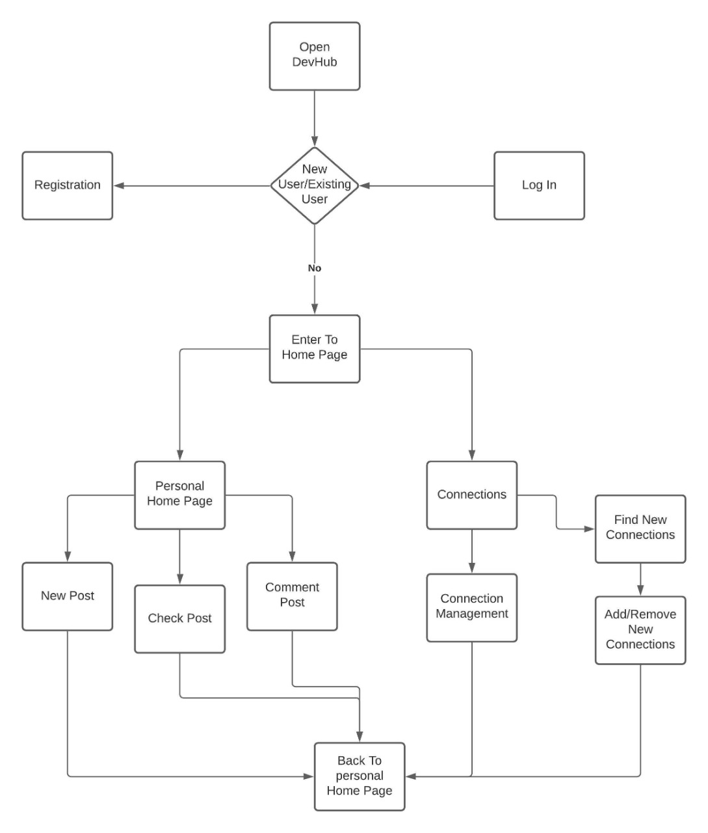

3.2 ALGORITHM
- Developing a website.
- Website will be developed using Web languages.
- A site based for developers.
- Developers will be able to connect, interact and share experiences among each other.
- Messaging functionality.
- Peer Programming.
- Recommendation System implementation.

CHAPTER-4
TECHNOLOGIES USED

FRONT-END: HTML, CSS, JAVASCRIPT, REACT
BACK-END: FIREBASE, NODEJS, TENSORFLOW
HOSTING: AWS

CHAPTER-5
DIAGRAM



CHAPTER-6
CONCLUSION

The gap between the developers can be reduced through this project. The project aims to eliminate the drawbacks of the existing resources and platforms for developers. The idea is to provide a sustainable platform for the developers and newbies to gain insights from experiences of senior developers and interact with them in order to move forward in the career field of their interest.

The project titled “DevelopersBay” will prove out to be beneficial and efficient for new generation developers in creating a network of developers and also for senior professionals to impart their work experiences to coming generations to make this tech world more efficient.

REFERENCES

[1] M. Abadi et al.,” TensorFlow: A System for Large-Scale Machine Learning,” presented at 12th USENIX Symposium on Operating System Design and Implementation (OSD’16). Savannah, GA, USA,2016.
[2] S.P. Sahu, A. Nautiyal, M. Prasad,” Machine Learning Algorithms for Recommender System -a comparative analysis, “International Journal of Computer Application Technology and Research, vol.6, no.2, Feb., pp.97-100,2017.
[3] M.I.Jordan,T.M.Mitchell,” Machine Learning: Trends, Perspectives and Prospects,” sciencemag.org,July .17,2015.[Online].Available:http://www.sciencemag.org .[Accessed Dec.4,2021].
[4] T.G. Dietterich,” Machine Learning Research: Four Current Directions,” AI Magazine, vol.18, no.4,1997.

